Employee Management
Step 1: Create new folder where you to install Django project. And open path in Visual Studio Code.
Step 2: Need to install virtualenv by below command.
pip install virtualenv
Step 3: Create new virtual environment.
virtualenv my_django_env
Step 4: To activate virtualenv
Click 'view'->Click 'command Palette'->Click 'Python: Select Interpreter'->Click 'Enter interpreter path'->Click 'find'->goto to your virtualenv->scripts->select python.exe file
Step 5: Open new terminal and see.
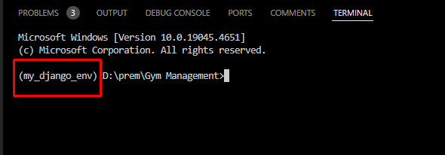
Step 6: Install Django by below command.
pip install django or specify version pip install django==3.0.2
Step 7: After install check this command to get al Django commands
django-admin
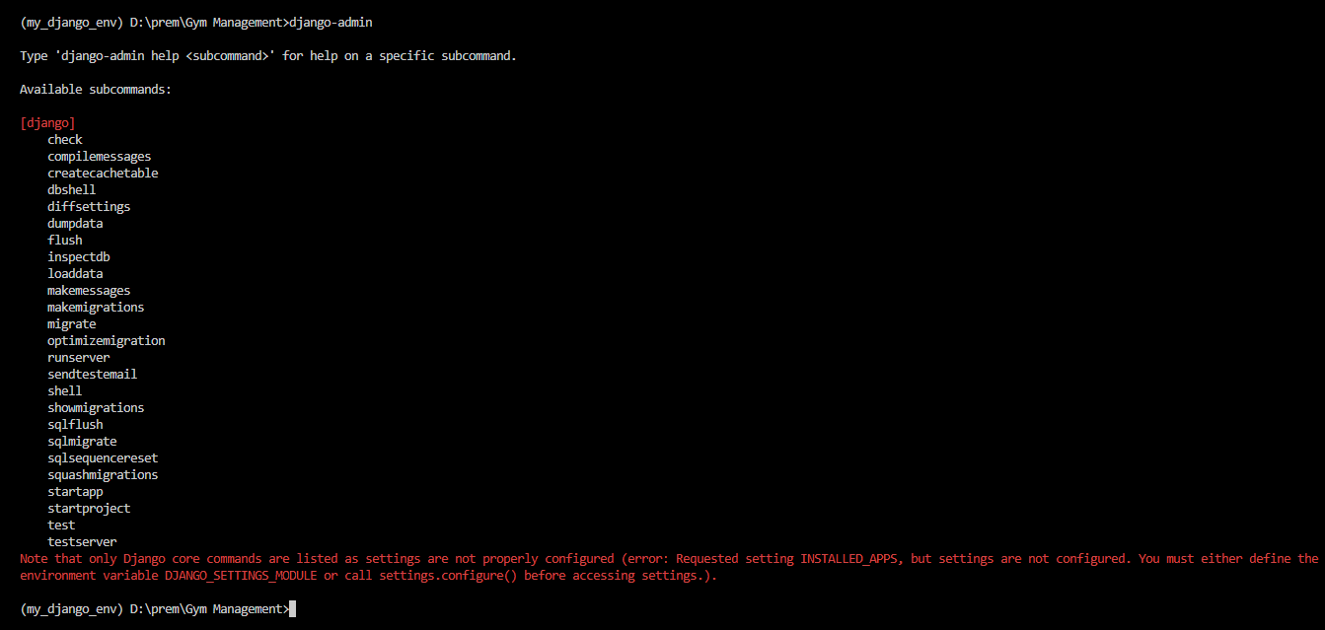
Step 8: Create Django project by below command.
django-admin startproject 'project-name'
If put . At end of command to create project in current folder
django-admin startproject 'project-name' .
Ex: django-admin startproject employee_management .

Step 9: Configure PostgreSQL Database. Install PostgreSQL dependency
pip install psycopg2
Change database configurations in settings.py file, here we configured PostgreSQL.
Install PostgreSQL and create database what you mentioned in config.
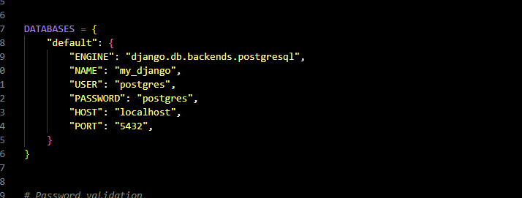
Why PostgreSQL:
- Advanced Features: PostgreSQL supports advanced features like JSONB for handling JSON data, full-text search, and custom data types, which can be beneficial for complex applications.
- ACID Compliance: It provides strong transactional integrity, ensuring reliable data handling and consistency.
- Concurrency Handling: With its MVCC (Multi-Version Concurrency Control), PostgreSQL handles multiple simultaneous transactions efficiently, which is crucial for high-traffic applications.
- Extensibility: PostgreSQL is highly extensible with support for various extensions, including PostGIS for geospatial data.
- Standards Compliance: PostgreSQL adheres closely to SQL standards, which can make it easier to work with and migrate to other systems if needed.
Step 10: To run below command to create tables from code.
python manage.py migrate
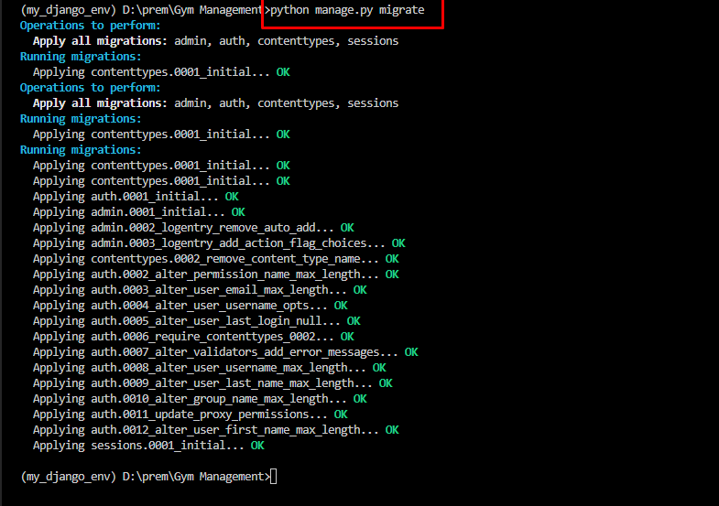
Step 11: To run Django project by below command.
python manage.py runserver
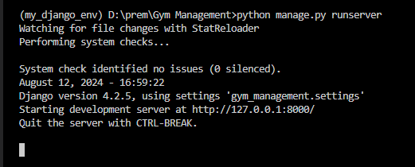

To click URL or open http://127.0.0.1:8000/
